**P6 – Design a control system**

**Introduction**

In this assignment, I will be explaining what my robot will do and the sensors of it. The robot is called ‘R3PTAR’. It acts like a ‘snake’ so it can move around like one. It has an infrared sensor, which detects any movement being held near its position within 3 to 5 cm. If anything is in front of the sensor, it attacks it just like a snake. I am hoping it can move around. Therefore, if anybody is behind, it can detect it, turn around and attack it.

**Pseudo code**

If (Infrared sensor is not active using your hand)

{

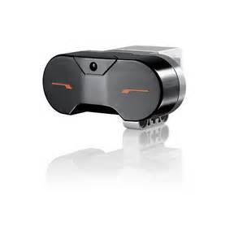 Robot will do nothing

}

If (infrared sensor is activated using your hand)

{

The robot will attack

}

{

While (the infrared sensor is active)

{

The robot will move back and forth aggressively

}

If (Infrared sensor is not pressed)

{

Robot will do nothing

}

}

**STORYBOARD**

**STEP 1**

This was before we added the infrared sensor. It shows that the difference between what was it before and what was it after. As you can see the picture below, we added the sensor so it looks like a ‘snake’.

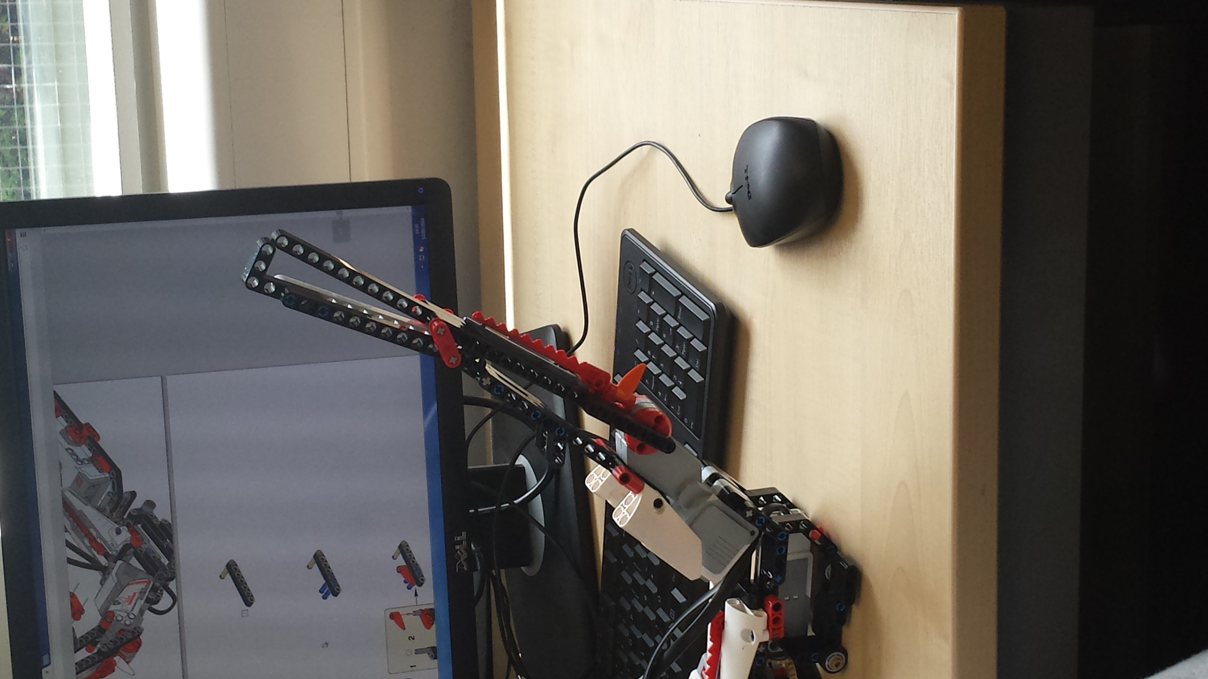

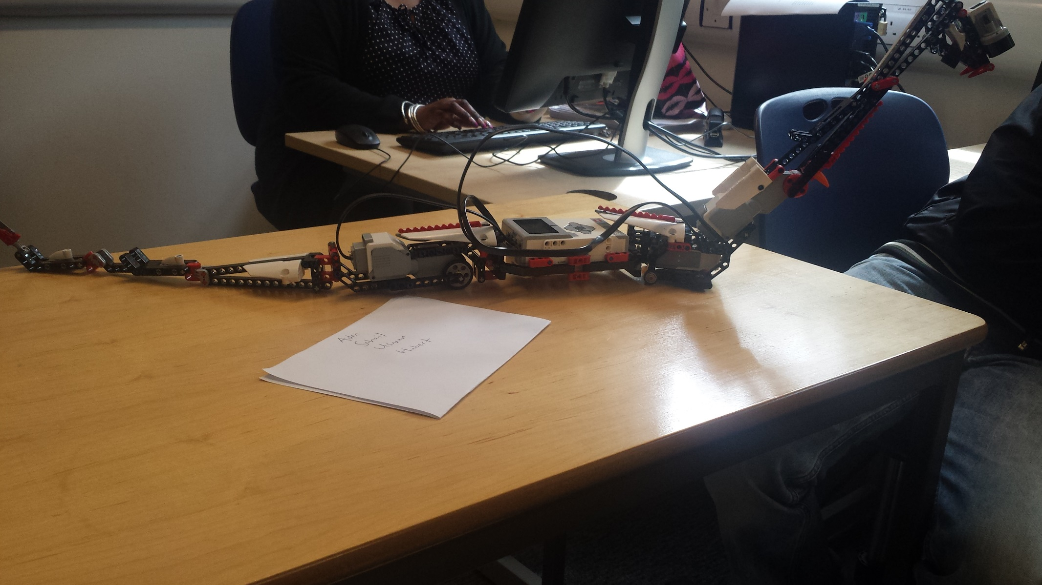

**STEP 2**

This whole picture is the updated version of the robot. The infrared sensor attacks when a hand has been placed in front of it. Nothing will happen if it has not been touched.

**STEP 3**

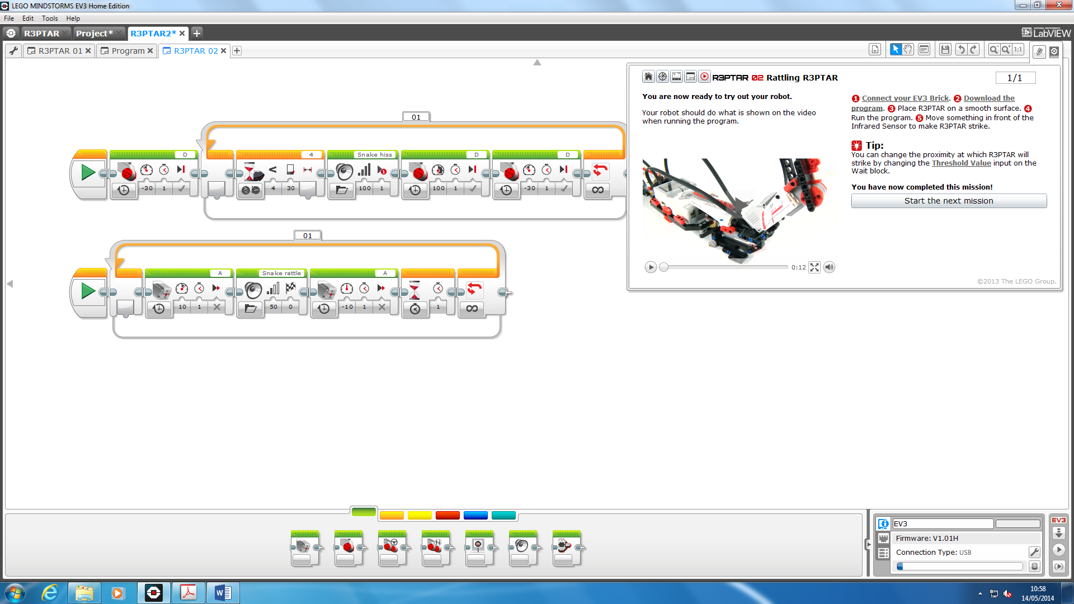

We used ‘EV3 LEGO Mindstorm Home Edition Software’ to program our work. We connected the controller with a USB to the computer so it can send instructions of the program. We programmed it. This was for the ‘infrared sensor’. All we needed to do is download the program onto our controller and test it. It was already on the system for it and we needed to put it on.

**STEP 4**

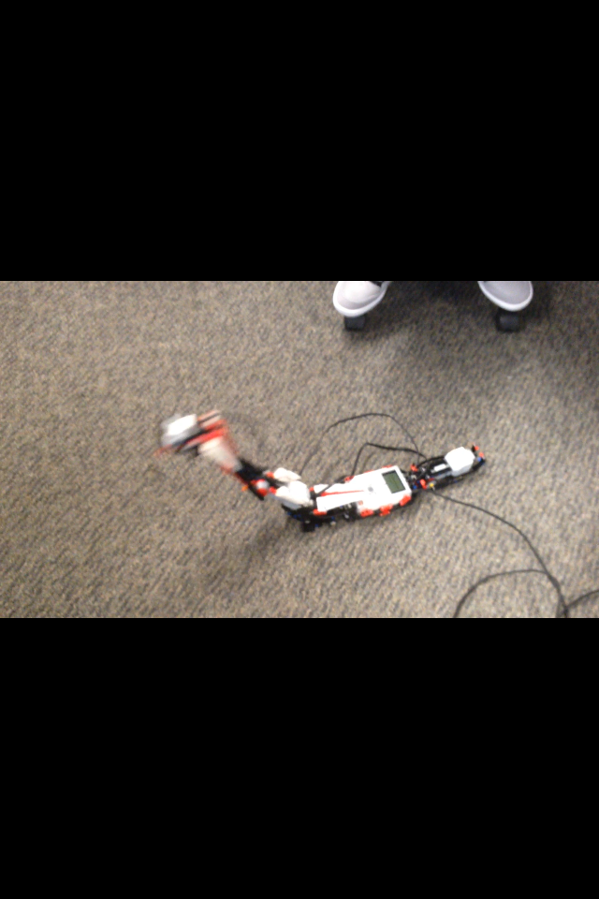

As you can see in the pictures, it is a process of how the infrared sensor works. First, the person needs to put their hand out infront of it. Once it has been detected, the snake attacks the person’s hand.

**D1 – Design a control system that uses different types of sensors**

**Introduction**

In this report, I will be explaining the additional sensor that I’ve added to the robot. I added the ‘touch sensor’. This is a sensor that attacks and moves at the same time. However, once the sensor has been pressed. It stops moving and it waits for 2 seconds and detects any hand-movement and only attacks. This shows that it has been linked and programmed with the infrared sensor so it has been programmed to stop.

**Pseudo code**

While (touch sensor is not active using your hand)

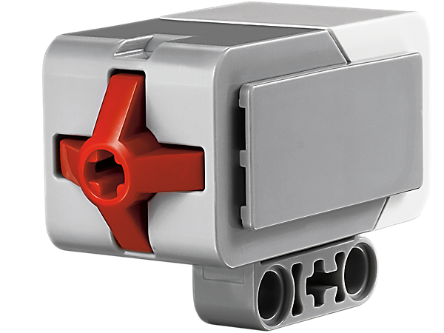 {

Robot will move straight ahead

Infrared sensor attacks anything that is anything front

}

If (touch sensor is activated by it being pressed)

{

The robot will stop moving

It will wait for 2 seconds

It will attack only using the infrared sensor

}

If (touch sensor is activated by it being pressed)

{

The robot detects anything in front of it

}

}

}

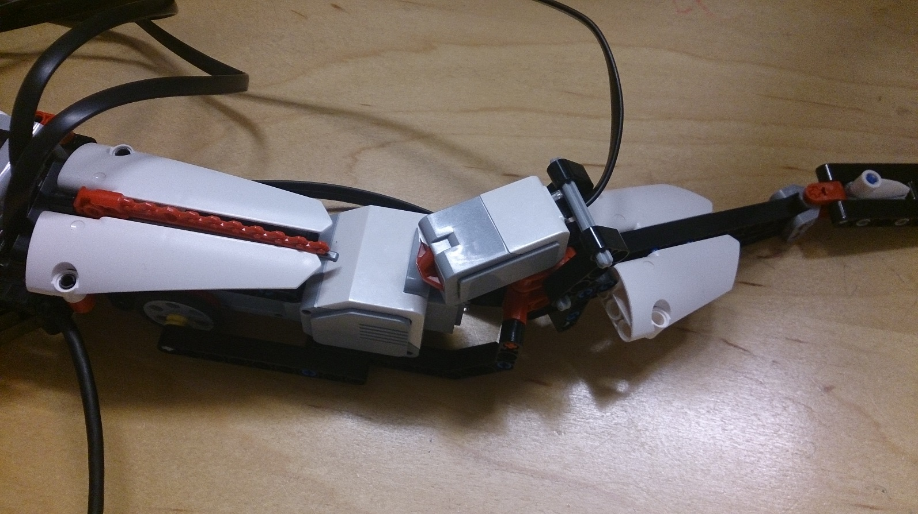**Storyboard**

**Step 1**

As you can see the whole image has been presented. The first image was ‘before’ the sensor was added. The second image shows where the sensor has been added. We added the sensor with a 5M cable to the controller for it to connect. We put it into 1st port to connect with the infrared sensor.

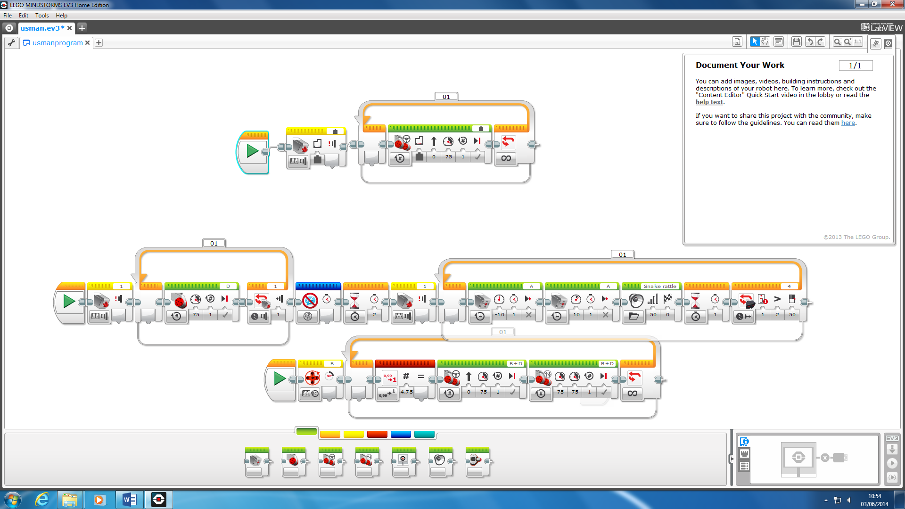**STEP 2**

We used ‘EV3 LEGO Mindstorm Home Edition Software’ to program our work. We connected the controller with a USB to the computer so it can send instructions of the program. We programmed it. It shows that we have to program it, give it specific instructions in order for it to work. We added the ‘infrared sensor’ to it and created our own ‘touch sensor’. We added the timing of it and put it all together for it to work.

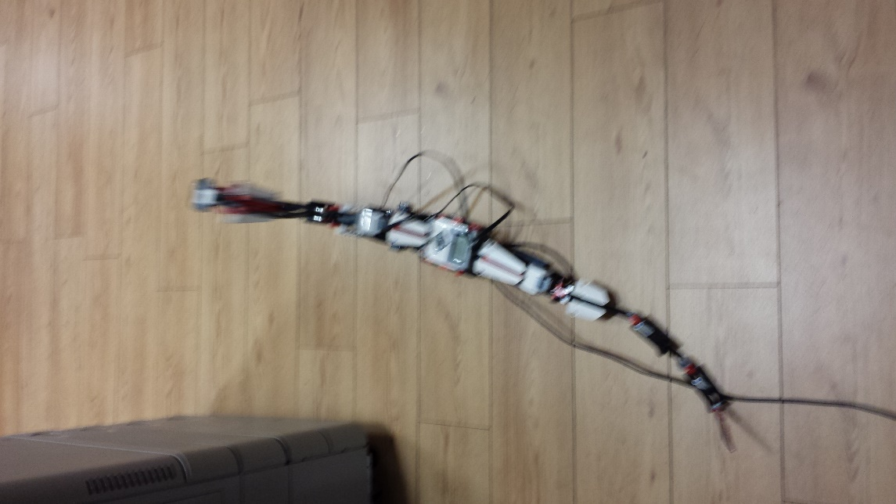**STEP 3**

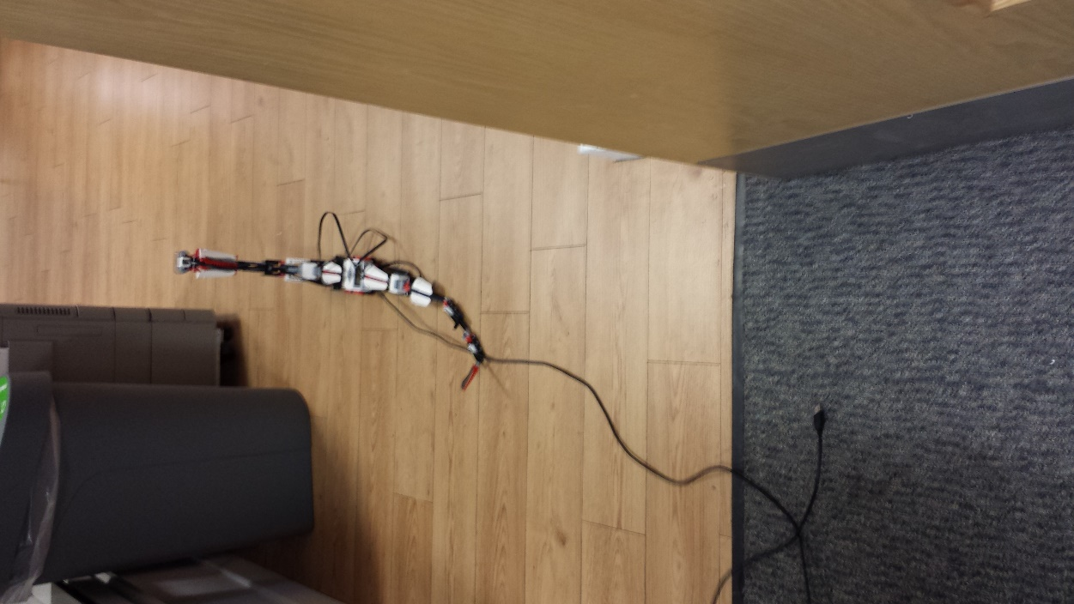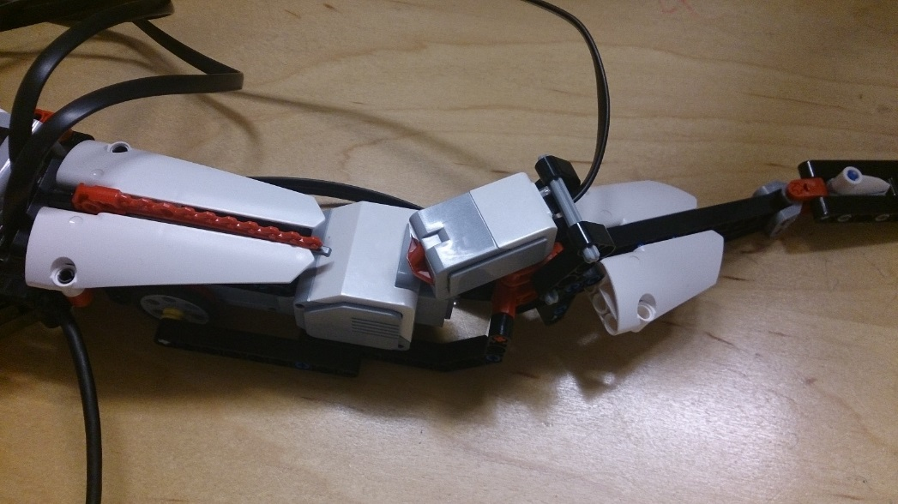

As you can see, these are the steps of how the ‘touch sensor’ works. Once the program has started, it attacks and moves at the same time. However, once the touch sensor has been pressed. It waits for 2 seconds and detects anything in front of it and attacks.